Application and API - Software Security Engineering and DevSecOps Program

Cybersecurity Lab

ProjectName: AccessGuard
Project SME: Sangita Maldole

A Secure Authentication System with Brute-Force Protection and Login Monitoring

2 | Technology Stack

This project uses the following technologies. Read each one carefully -- you will be asked questions about them.

Technology | Category | What It Does In This Project
Python 3 | Programming Language | The main language used to write all the server-side logic
FastAPI | Web Framework | Handles all URLs, form submissions, and API endpoints
SQLite | Database | Stores user accounts and login attempt records in a local file
Jinja2 | HTML Templating | Let's Python inject live data (like error messages) into HTML pages
Hashlib | Security Library | Converts plain-text passwords into SHA-256 hashes before storing
python-multipart | Form Data Handler | Allows FastAPI to read data submitted from HTML forms
Uvicorn | Web Server | Runs the FastAPI application so it can be accessed in a browser
HTML + CSS | Frontend | Simple web pages for login, register, dashboard, and welcome

3 | Scope

The Cybersecurity Secure Login and monitoring system is a web application that demonstrates the following five core security principles through a working, interactive system:
- Password Hashing using SHA-256 via Python hashlib
- Brute-Force Protection via automatic account lockout after 3 failed login attempts
- Login Monitoring through a persistent audit log of all login events
- Role-Based Access Control (RBAC) directs Admins and Users to separate pages
- SQL Injection Prevention through parameterized database queries
:

Page / Feature | What It Does | URL
Home Page | Landing page with links to Login and Register | /
Register Page | New users create an account with a username, email, password, and role | /register
Login Page | Users enter their email and password to log in | /login
Welcome Page | Regular users land here after a successful login | /welcome
Admin Dashboard | Admins see all login attempts, timestamps, and locked accounts | /dashboard
Unlock Account | Admin can reset a locked account with one click | /unlock/{email}
JSON API | Developers can test all features using /docs (Swagger UI) | /api/...

Purpose and Takeaway

This project is not just about building a Secure login system, but its work as a whole monitoring system. It is about understanding the security principles that protect real users in real systems. Every line of code in this project maps to a concept that is tested in cybersecurity interviews and used in production applications every day.

 | Cyber Security Concept through real-time project
01 | Password Hashing (SHA-256)
02 | Brute-Force Protection
03 | Login Monitoring & Audit Logs
04 | Role-Based Access Control
05 | SQL Injection Prevention

DFD –Data Flow Diagram

The context diagram shows the Cybersecurity Login and monitoring. It identifies all external entities that interact with the system and the top-level data flows between them.
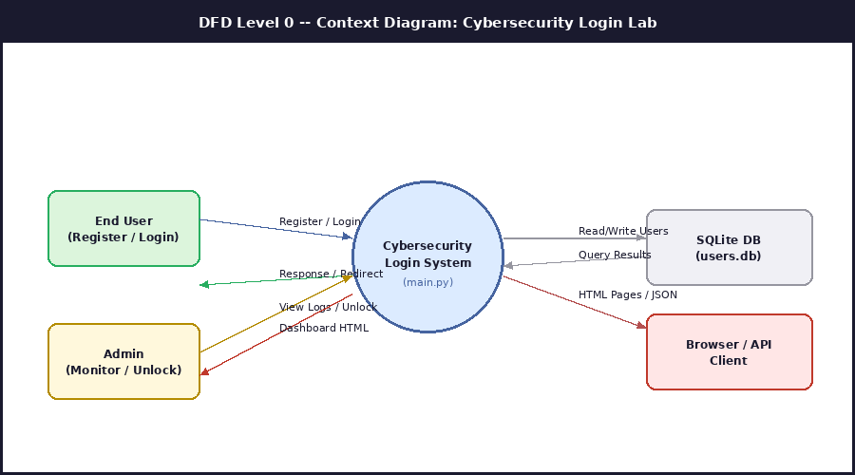
Figure 1: DFD Level 0 -- Context Diagram showing external entities and top-level data flows

External Entities:
Entity | Description
End User | Registers a new account or logs in. Receives HTML responses and redirect instructions.
Admin | Views the login monitoring dashboard and unlocks locked accounts.
SQLite DB | Stores and retrieves user records and login log entries.
Browser / API | The client interface through which users and developers interact with the system.

